1-Create a table for Customer.
Column Name Format
cust_id char(5)
Lname char(15)
Fname char(15)
Area char(2)
phone_no number(8)
SOLUTION:
create table Customer (
cust_id char(5),
Lname char(15),
Fname char(15),
Area char(2),
phone_no number(8));

Describe Customer;

2-Create a table for Movie
Column Name Format
mv_no number (5)
Title char(25)
Type char(10)
Star char(25)
Price number(8,2)
SOLUTION:
create table Movie (
mv_no number (5),
Title char(25),
Type char(10),
Star char(25),
Price number(8,2));

Describe movie;
3- Create a table for invoice
Column Name Format
inv_no char(3)
mv_no number(5)
cust_id char(5)
issue_date date
return_date date

SOLUTION:
create table invoice
(
inv_no char(3),
mv_no number(5),
cust_id char(5),
issue_date date,
return_date date
);

Describe invoice;
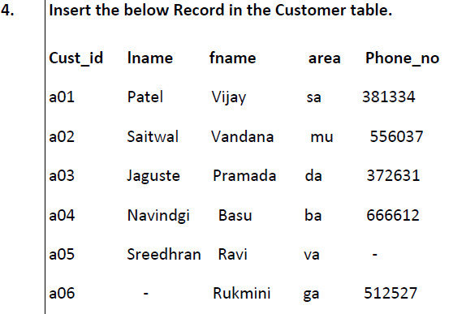
SOLUTION:
1->
Insert into Customer( cust_id, Lname ,Fname,Area ,phone_no) values ('a01','Patel','Vijay','sa',381334);

Output:
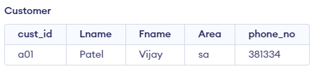

2-> Insert into Customer( cust_id, Lname ,Fname,Area ,phone_no) values ('a02', 'Saitwal', 'Vandana', 'mu', 556037);
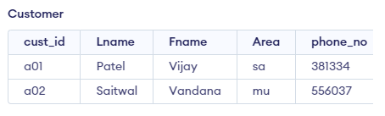

3-> Insert into Customer( cust_id, Lname ,Fname,Area ,phone_no) values ('a03', 'Jaguste', 'Pramada', 'da', 372631);
4-> Insert into Customer( cust_id, Lname ,Fname,Area ,phone_no) values ('a04', 'Navindgi', 'Basu', 'ba', 666612);
5-> Insert into Customer( cust_id, Lname ,Fname,Area ) values ('a05', 'Sreedhran', 'Ravi', 'va');
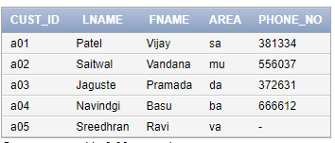
6-> Insert into Customer( cust_id, Lname ,Fname,Area ,phone_no) values ('a06', ' ', 'Rukmini', 'ga',512527);
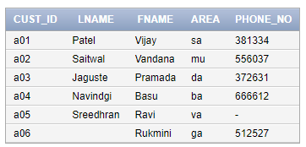

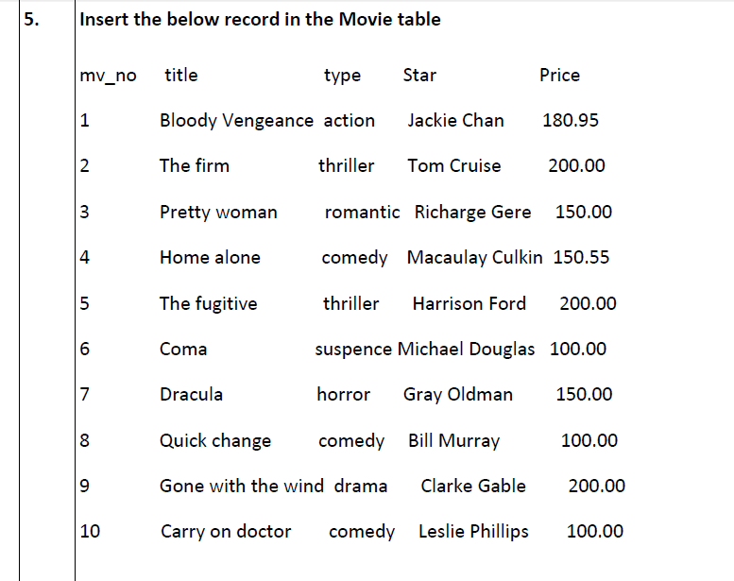
SOLUTION:
1-> Insert into Movie (mv_no,Title,Type,Star,Price) values (1,'Bloody Vengeance',' action','Jackie Chan', 180.95);

2-> Insert into Movie (mv_no,Title,Type,Star,Price) values (2,'The firm',' thriller','Tom Cruise', 200.00);
3-> Insert into Movie (mv_no,Title,Type,Star,Price) values (3,'Pretty woman',' romantic','Richarge Gere', 150.00);
4-> Insert into Movie (mv_no,Title,Type,Star,Price) values (4,'Home alone',' comedy','Macaulay Culkin', 150.55);
5-> Insert into Movie (mv_no,Title,Type,Star,Price) values (5,'The fugitive',' thriller','Harrison Ford', 200.00);
6-> Insert into Movie (mv_no,Title,Type,Star,Price) values (6,'Coma',' suspence','Michael Douglas', 100.00);
7-> Insert into Movie (mv_no,Title,Type,Star,Price) values (7,'Dracula',' horror','Gray Oldman', 150.00);
8-> Insert into Movie (mv_no,Title,Type,Star,Price) values (8,'Quick change',' comedy','Bill Murray', 100.00);
9-> Insert into Movie (mv_no,Title,Type,Star,Price) values (9,'Gone with the wind',' drama','Clarke Gable', 200.00);
10-> Insert into Movie (mv_no,Title,Type,Star,Price) values (10,'Carry on doctor',' comedy','Leslie Phillips', 100.00);
->select * from Movie;
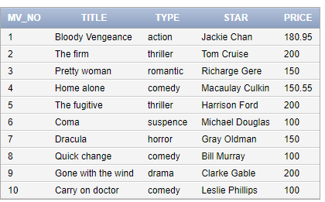

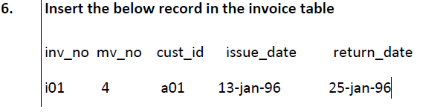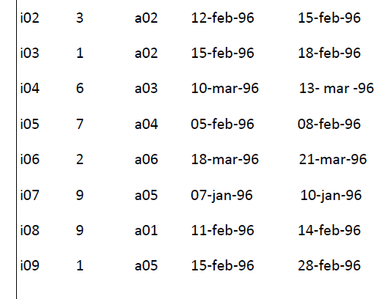

create table invoice
(
inv_no char(3),
mv_no number(5),
cust_id char(5),
issue_date date,
return_date date
);
describe invoice;

SOLUTION:

1-> Insert into invoice (inv_no, mv_no, cust_id, issue_date, return_date) values ('i01',4,'a01', TO_DATE('13-jan-1996', 'DD/MM/YYYY'),TO_DATE('25-jan-1996', 'DD/MM/YYYY'));
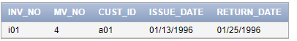

2-> Insert into invoice (inv_no, mv_no, cust_id, issue_date, return_date) values ('i02',3,'a02', TO_DATE('12-feb-1996', 'DD/MM/YYYY'),TO_DATE('15-feb-1996', 'DD/MM/YYYY'));
3-> Insert into invoice (inv_no, mv_no, cust_id, issue_date, return_date) values ('i03',1,'a02', TO_DATE('15-feb-1996', 'DD/MM/YYYY'),TO_DATE('18-feb-1996', 'DD/MM/YYYY'));
4-> Insert into invoice (inv_no, mv_no, cust_id, issue_date, return_date) values ('i04',6,'a03', TO_DATE('10-mar-1996', 'DD/MM/YYYY'),TO_DATE('13-mar-1996', 'DD/MM/YYYY'));
5-> Insert into invoice (inv_no, mv_no, cust_id, issue_date, return_date) values ('i05',7,'a04',TO_DATE('5-feb-1996', 'DD/MM/YYYY') ,TO_DATE('8-feb-1996', 'DD/MM/YYYY'));
6-> Insert into invoice (inv_no, mv_no, cust_id, issue_date, return_date) values ('i06',2,'a06',TO_DATE('18-mar-1996', 'DD/MM/YYYY') ,TO_DATE('21-mar-1996', 'DD/MM/YYYY'));
7-> Insert into invoice (inv_no, mv_no, cust_id, issue_date, return_date) values ('i07',9,'a05', TO_DATE('07-jan-1996', 'DD/MM/YYYY'),TO_DATE('10-jan-1996', 'DD/MM/YYYY'));
8-> Insert into invoice (inv_no, mv_no, cust_id, issue_date, return_date) values ('i08',9,'a01', TO_DATE('11-feb-1996', 'DD/MM/YYYY'), TO_DATE('14-feb-1996', 'DD/MM/YYYY'));
9->Insert into invoice (inv_no, mv_no, cust_id, issue_date, return_date) values ('i09',1,'a05',TO_DATE('15-feb-1996', 'DD/MM/YYYY') ,TO_DATE('28-feb-1996', 'DD/MM/YYYY'));
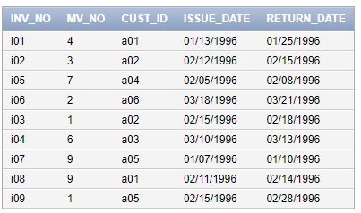

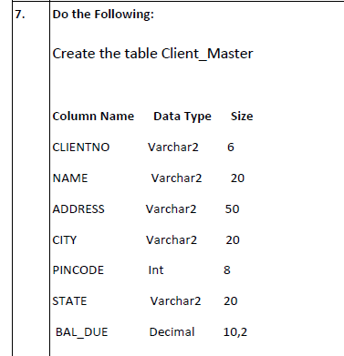
SOLUTION:
CREATE table Client_Master(CLIENTNO varchar2(6),NAME varchar2(20),ADDRESS varchar2(50),CITY varchar2(20),PINCODE number(8),STATE varchar2(20),BAL_DUE number(10,2));
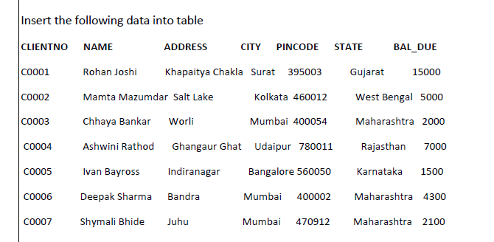
SOLUTION:
1-> insert into Client_Master(CLIENTNO,NAME,ADDRESS,CITY,PINCODE,STATE,BAL_DUE) values ('C0001','Rohan Joshi','Khapaitya Chakla','Surat',395003,'Gujarat',15000);
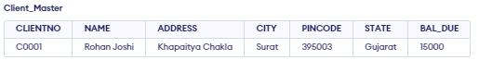
2-> insert into Client_Master(CLIENTNO,NAME,ADDRESS,CITY,PINCODE,STATE,BAL_DUE) values ('C0002','Mamta Mazumdar','Salt Lake','Kolkata',460012,'West Bengal',5000);
3-> insert into Client_Master(CLIENTNO,NAME,ADDRESS,CITY,PINCODE,STATE,BAL_DUE) values ('C0003','Chhaya Bankar','Worli','Mumbai',400054,'Maharashtra',2000);
4-> insert into Client_Master(CLIENTNO,NAME,ADDRESS,CITY,PINCODE,STATE,BAL_DUE) values ('C0004','Ashwini Rathod','Ghangaur Ghat','Udaipur',780011,'Rajasthan',7000);
5-> insert into Client_Master(CLIENTNO,NAME,ADDRESS,CITY,PINCODE,STATE,BAL_DUE) values ('C0005','Ivan Bayross','Indiranagar','Bangalore',560050,'Karnataka',1500);
6-> insert into Client_Master(CLIENTNO,NAME,ADDRESS,CITY,PINCODE,STATE,BAL_DUE) values ('C0006','Deepak Sharma','Bandra','Mumbai',400002,'Maharashtra',4300);
7-> insert into Client_Master(CLIENTNO,NAME,ADDRESS,CITY,PINCODE,STATE,BAL_DUE) values ('C0007','Shymali Bhide','Juhu','Mumbai',470912,'Maharashtra',2100);
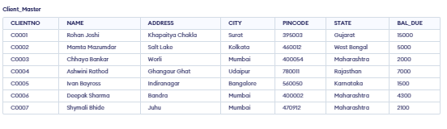

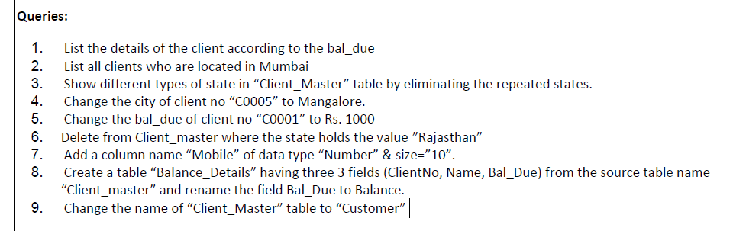

Queries solution:
1-> SELECT * FROM CLIENT_MASTER ORDER BY BAL_DUE DESC;
2-> select * from Client_Master where city='Mumbai';
3-> select state from Client_Master;
-> select distinct state from Client_Master;
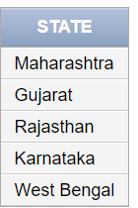
4-> update Client_Master set city='Mangalore' where CLIENTNO ='C0005';
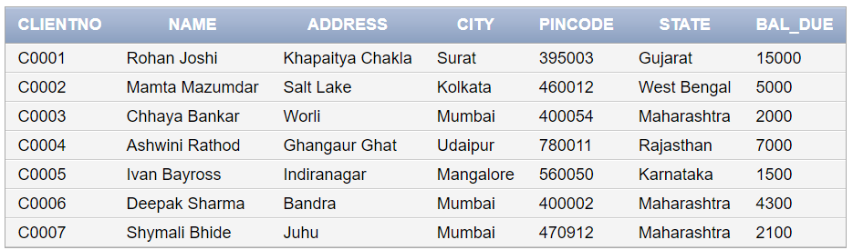
5-> update Client_Master set BAL_DUE =1000 where CLIENTNO ='C0001';
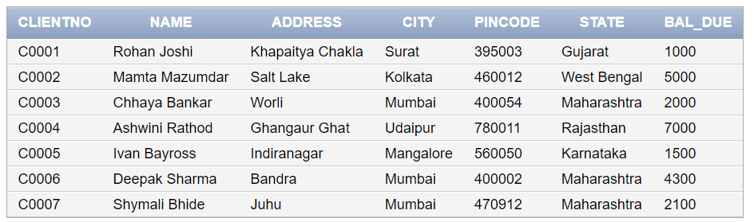
6-> delete from client_master where STATE='Rajasthan';
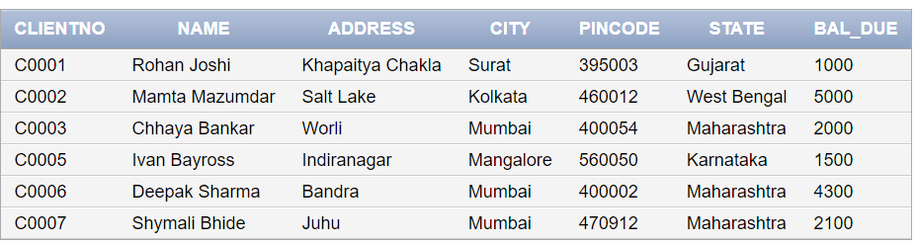
7-> ALTER TABLE Client_Master ADD(Mobile number(10));
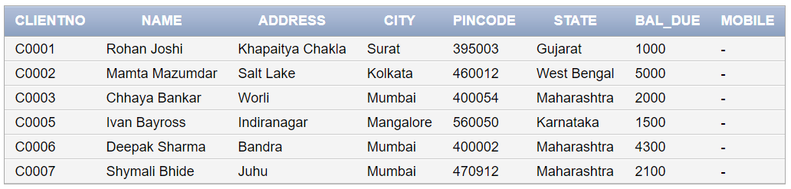
8-> create table Balance_Details(ClientNo, Name, Bal_Due) AS SELECT CLIENTNO,NAME,BAL_DUE from Client_Master;
->describe Balance_Details;
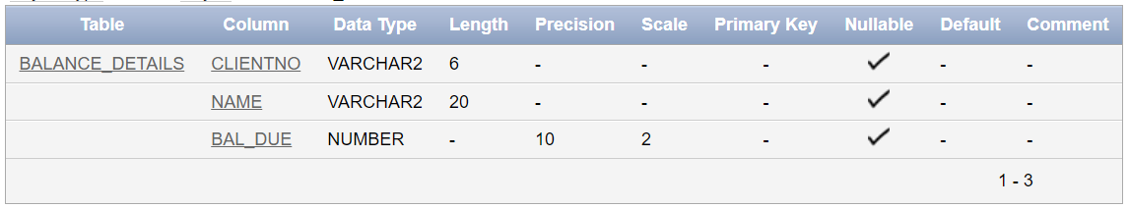
9-> RENAME Client_Master TO Customer_new;
-> select * from Customer_new;
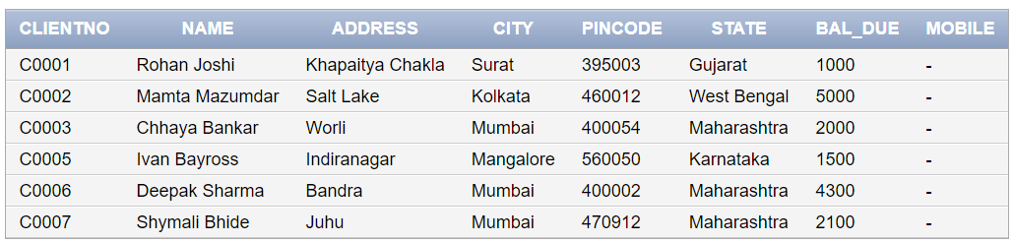
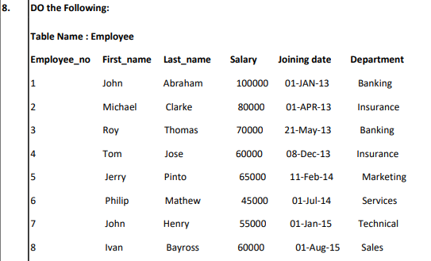

create table Employee
(
Employee_no number(3) primary key,
First_name varchar2(20),
Last_name varchar2(20),
Salary number(8),
Joining_date date,
Department varchar2(20)
);

-> describe Employee;
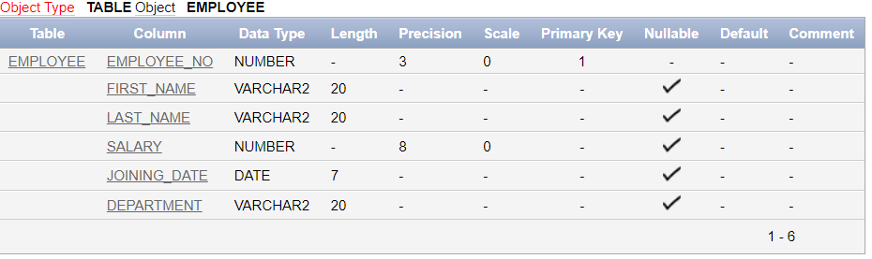
Insert records:
1->Insert into Employee (Employee_no, First_name, Last_name, Salary, Joining_date, Department) values (1,'John','Abraham',100000,TO_DATE('01-jan-2013','DD/MM/YYYY'),'Banking');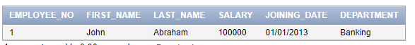

2-> Insert into Employee (Employee_no, First_name, Last_name, Salary, Joining_date, Department) values (2,'Michael','Clarke',80000,TO_DATE('01-apr-2013','DD/MM/YYYY'),'Insurance');
3-> Insert into Employee (Employee_no, First_name, Last_name, Salary, Joining_date, Department) values (3,'Roy','Thomas',70000,TO_DATE('21-may-2013','DD/MM/YYYY'),'Banking');
4-> Insert into Employee (Employee_no, First_name, Last_name, Salary, Joining_date, Department) values (4,'Tom','Jose',60000,TO_DATE('08-dec-2013','DD/MM/YYYY'), 'Insurance');
5-> Insert into Employee (Employee_no, First_name, Last_name, Salary, Joining_date, Department) values (5,'Jerry','Pinto',65000,TO_DATE('11-feb-2014','DD/MM/YYYY'), 'Marketing');
6-> Insert into Employee (Employee_no, First_name, Last_name, Salary, Joining_date, Department) values (6,'Philip','Mathew',45000,TO_DATE('01-jul-2014','DD/MM/YYYY'), 'Services');
7-> Insert into Employee (Employee_no, First_name, Last_name, Salary, Joining_date, Department) values (7,'John','Henry',55000,TO_DATE('01-jan-2015','DD/MM/YYYY'), 'Technical');
8-> Insert into Employee (Employee_no, First_name, Last_name, Salary, Joining_date, Department) values (8,'Ivan','Bayross',60000,TO_DATE('01-aug-2015','DD/MM/YYYY'), 'Sales');
-> select * from employee;
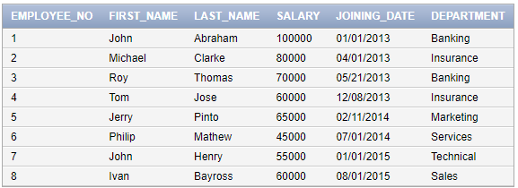
______________________________________________

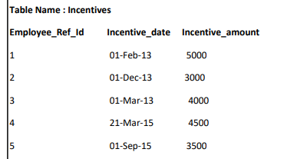

create table Incentives
(
Employee_Ref_Id number(3) ,
Incentive_date date,
Incentive_amount number(5),
Foreign key (Employee_Ref_Id) references employee
);

-> describe Incentives;
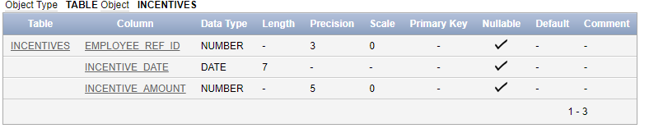

Insert records:

-> Insert into Incentives (Employee_Ref_Id, Incentive_date, Incentive_amount) values (1, TO_DATE('01-feb-2013','DD/MM/YYYY'), 5000);
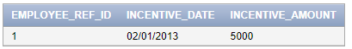
-> Insert into Incentives (Employee_Ref_Id, Incentive_date, Incentive_amount) values (2, TO_DATE('01-dec-2013','DD/MM/YYYY'), 3000);
-> Insert into Incentives (Employee_Ref_Id, Incentive_date, Incentive_amount) values (3, TO_DATE('01-mar-2013','DD/MM/YYYY'), 4000);
-> Insert into Incentives (Employee_Ref_Id, Incentive_date, Incentive_amount) values (4, TO_DATE('21-mar-2015','DD/MM/YYYY'), 4500);
-> Insert into Incentives (Employee_Ref_Id, Incentive_date, Incentive_amount) values (5, TO_DATE('01-sep-2015','DD/MM/YYYY'), 3500);

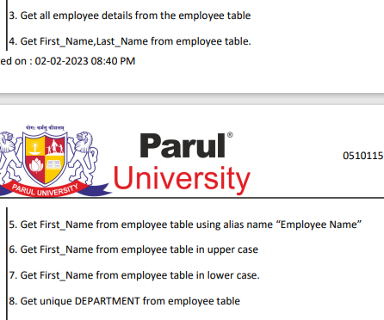
Queries solution:

3-> select * from employee;
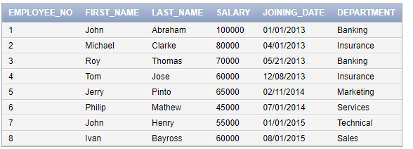
4-> select first_name,Last_name from employee;
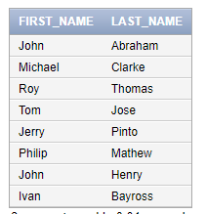
5-> select first_name "Employee Name" from employee;
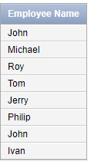
6-> select lower(first_name) from employee;
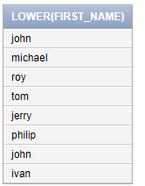
7-> select upper(first_name) from employee;
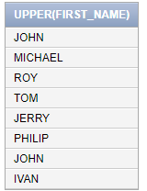
8-> select distinct department from employee;
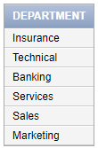

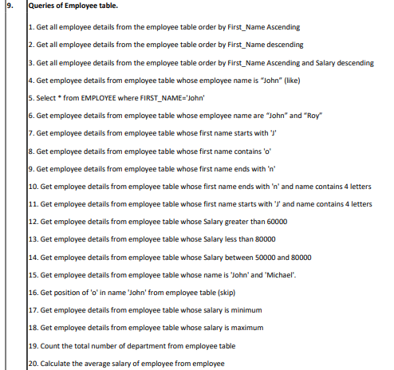
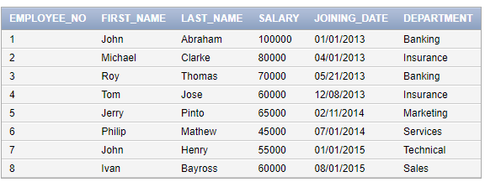
Queries solution:

1->[ Get all employee details from the employee table order by First_Name Ascending]
->select * from employee order by first_name asc;
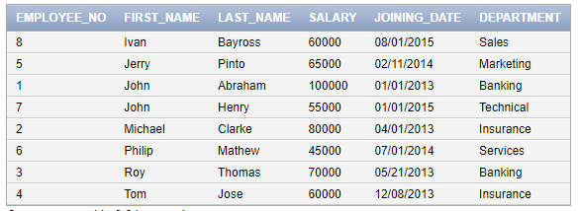
2->[ Get all employee details from the employee table order by First_Name descending]
->select * from employee order by first_name desc;
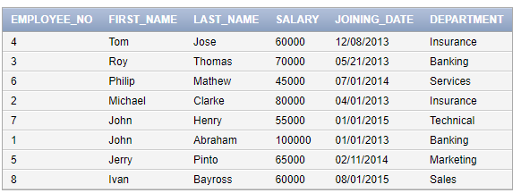
3-> select * from employee order by first_name asc, salary desc;
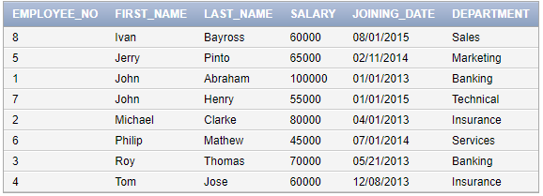

4-> [Get employee details from employee table whose employee name is “John” (USING like H/W)]
->Select * from EMPLOYEE where FIRST_NAME='John';
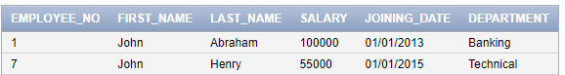
5->same above query

6->[ Get employee details from employee table whose employee name are “John” and “Roy”]
->select * from employee where first_name in('John','Roy');
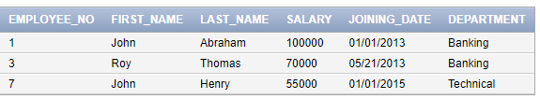
7->[ Get employee details from employee table whose first name contains 'J']
->select * from employee where first_name like 'J%';
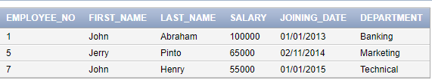
8-> [H/W]
9->[ Get employee details from employee table whose first name ends with 'n']
->select * from employee where first_name like '%n';
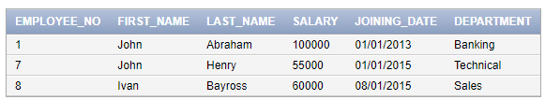
10->[ 10. Get employee details from employee table whose first name ends with 'n' and name contains 4 letters]
->select * from employee where first_name like '___n'; (hint:four underscore)
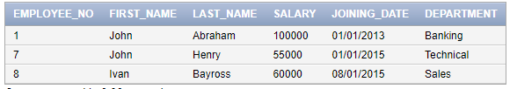
11-> [Get employee details from employee table whose first name starts with 'J' and name contains 4 letters]
->select * from employee where first_name like 'J___';
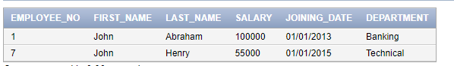
12->[ Get employee details from employee table whose Salary greater than 60000]
->select * from employee where salary>60000;
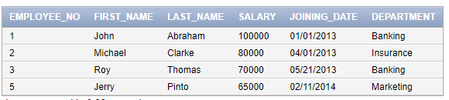
13->[ Get employee details from employee table whose Salary less than 80000]
->select * from employee where salary<80000;
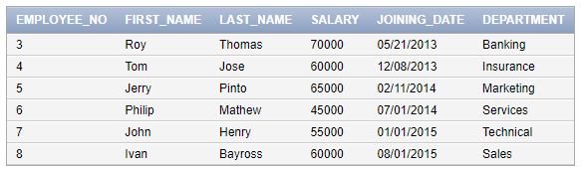
14->[ Get employee details from employee table whose Salary between 50000 and 80000]
->select * from employee where salary between 50000 and 80000;
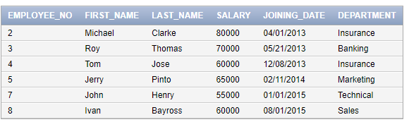
15-> [Get employee details from employee table whose name is 'John' and 'Michael'.]
->select * from employee where first_name in('John','Michael');
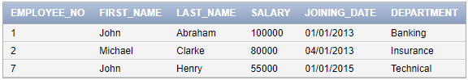
16->[ Get position of 'o' in name 'John' from employee table ]
->select instr(first_name,'o') "position" from employee where first_name='John';
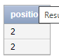
17-> [Get employee details from employee table whose salary is minimum]
->select * from employee where salary=(select min(salary) from employee);
18->[ Get employee details from employee table whose salary is maximum]
->select * from employee where salary=(select max(salary) from employee);
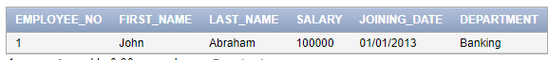
19->[ Count the total number of department from employee table]
->select count(distinct(department)) "No of department" from employee;
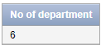
20->[ Calculate the average salary of employee from employee]
->select avg(salary)"Average Salary" from employee;
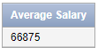
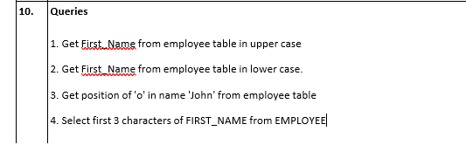
Queries solution:

1->[ Get First_Name from employee table in upper case]
->select upper(first_name) from employee;
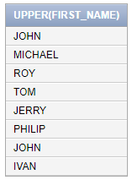
2-> [Get First_Name from employee table in lower case.]
->select lower(first_name) from employee;
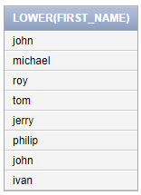
3->[ Get position of 'o' in name 'John' from employee table]
-> select instr(first_name,'o') "position" from employee where first_name='John';

4->[ Select first 3 characters of FIRST_NAME from EMPLOYEE]
-> select substr(first_name,1,3) from employee;
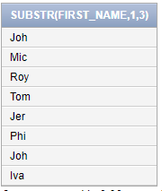

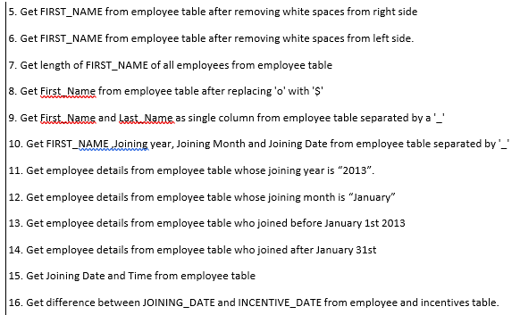
Queries solution:

5-> [ Get FIRST_NAME from employee table after removing white spaces from left side.]
->select ltrim(first_name,' ') from employee;
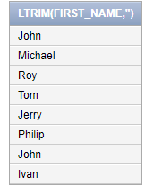
6->[Get FIRST_NAME from employee table after removing white spaces from right side]
->select rtrim(first_name,' ') from employee;
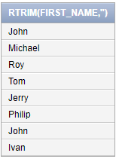
7->[ Get length of FIRST_NAME of all employees from employee table]
->select length(first_name) "length", first_name from employee;
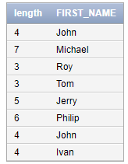
8-> [Get First_Name from employee table after replacing 'o' with '$']
->select first_name, replace(first_name,'o','$') from employee;
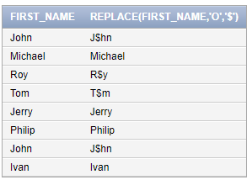

9->[ Get First_Name and Last_Name as single column from employee table separated by a '_']
->select first_name|| '-' || last_name from employee;
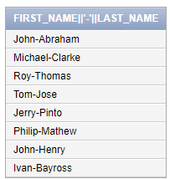
10->[ Get FIRST_NAME ,Joining year, Joining Month and Joining Date from employee table separated by '_']
->select first_name,to_char(joining_date,'yyyy') "Joing Year",to_char(joining_date,'mon')"Month",to_char(joining_date,'dd') "Day" from employee;
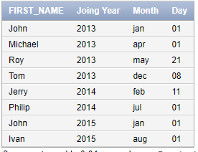
11->[ Get employee details from employee table whose joining year is “2013”.]
->select * from employee where to_char(joining_date,'yyyy')='2013';
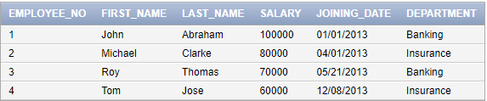
12->[ Get employee details from employee table whose joining month is “January”]
->select * from employee where to_char(joining_date,'mon')='jan';
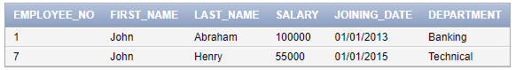
13->[ Get employee details from employee table who joined before January 1st 2013]
->select * from employee where joining_date < to_date('01/01/2012','dd/mm/yyyy');
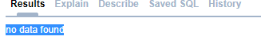
14->[ Get employee details from employee table who joined after January 31st]
->select * from employee where joining_date > to_date('31/01/2013','dd/mm/yyyy');
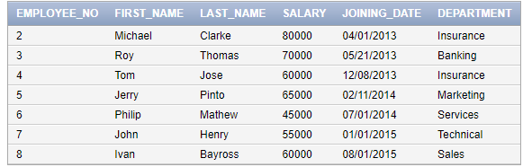
15->[ Get Joining Date and Time from employee table]
->select first_name,to_char(joining_date,'dd/mm/yyyy hh:mi:ss') "Joining Date with Time" from employee;
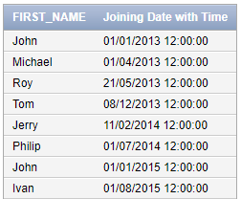
16-> [Get difference between JOINING_DATE and INCENTIVE_DATE from employee and incentives table.]
->select first_name,incentive_date-joining_date from employee e inner join incentives i on e.employee_no=i.employee_ref_id;
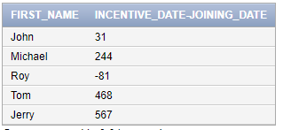

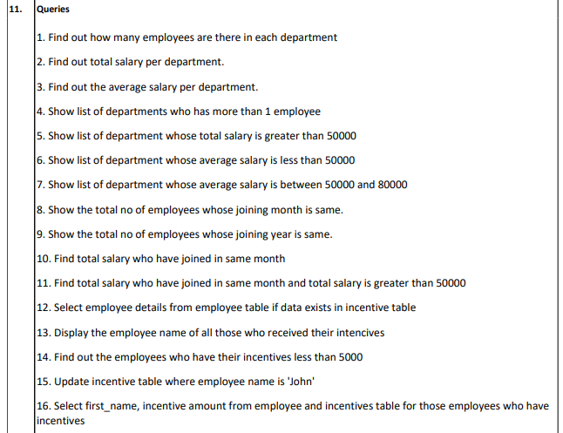
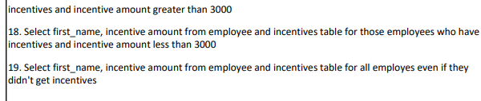
Queries solution:
1->[ Find out how many employees are there in each department]
->select count(first_name) "No. of Employee",department from employee group by department;
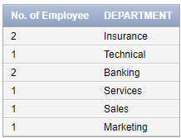
2-> [Find out total salary per department.]
->select department,sum(salary) "Total Salary" from employee group by department;
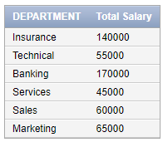
3->[ Find out the average salary per department.]
->select department,avg(salary) "Average Salary" from employee group by department;
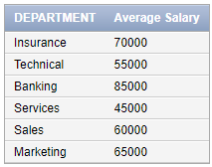
4->[ Show list of departments who has more than 1 employee]
-> select department from employee group by department having count(*)>1;
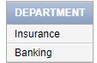
5->[ Show list of department whose total salary is greater than 50000]
-> select department,sum(salary) "Total Salary >50000" from employee group by department having sum(salary)>50000;
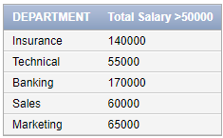
6->[ Show list of department whose average salary is less than 50000]
-> select department,avg(salary) "Average Salary <50000" from employee group by department having avg(salary)<50000;
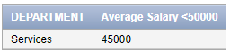
7-> [Show list of department whose salary is between 50000 and 80000]
->select * from employee where salary between 50000 and 80000;
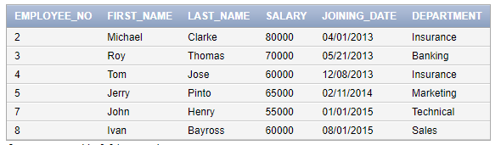
8->[ Show the total no of employees whose joining month is same.]
-> select count(employee_no) "No. of Employee",to_char(joining_date,'mon')"Same Month" from employee group by to_char(joining_date,'mon') having count(employee_no)>1;
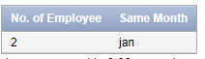
9->[ Show the total no of employees whose joining year is same.]
-> select count(employee_no) "No. of Employee",to_char(joining_date,'yyyy') "Same Joing Year" from employee group by to_char(joining_date,'yyyy') having count(employee_no)>1;
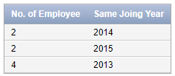
10->[ Find total salary who have joined in same month]
-> select sum(salary) "Total Salary",to_char(joining_date,'mon')"Same Month" from employee group by to_char(joining_date,'mon') having count(employee_no)>1;
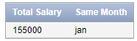
11->[ Find total salary who have joined in same month and total salary is greater than 50000]

-> select sum(salary) "Total Salary > 50000",to_char(joining_date,'mon')"Same Month" from employee group by to_char(joining_date,'mon') having count(employee_no)>1 and sum(salary)>50000;
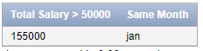
12->[ Select employee details from employee table if data exists in incentive table]
-> select * from employee where employee_no IN (select employee_ref_id from incentives);
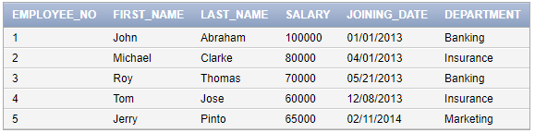
13->[ Display the employee name of all those who received their intencives]
-> select first_name "Received Their Intencives" from employee where employee_no IN (select employee_ref_id from incentives);
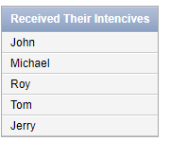
14->[ Find out the employees who have their incentives less than 5000]
-> select first_name"Incentive <5000" from employee where employee_no IN (select employee_ref_id from incentives where incentive_amount<5000);
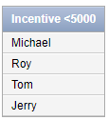
15->[ Update incentive table where employee name is 'Roy']
-> update incentives set incentive_amount='5500' where employee_ref_id=(select employee_no from employee where first_name='Roy');
-> select * from incentives;
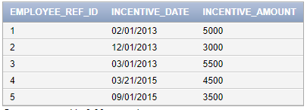
16->[ Select first_name, incentive amount from employee and incentives table for those employees who have incentives]
-> select first_name,incentive_amount from employee e inner join incentives i on e.employee_no=i.employee_ref_id;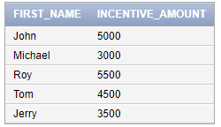
17->[ Select first_name, incentive amount from employee and incentives table for those employees who have incentives and incentive amount greater than 3000
]
-> select first_name,incentive_amount from employee e inner join incentives i on e.employee_no=i.employee_ref_id and incentive_amount >3000;
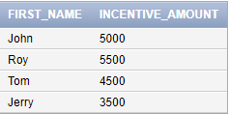
18->[ Select first_name, incentive amount from employee and incentives table for those employees who have incentives and incentive amount less than 4000]
-> select first_name,incentive_amount from employee e inner join incentives i on e.employee_no=i.employee_ref_id and incentive_amount <4000;
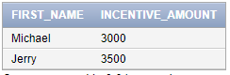
19->[ Select first_name, incentive amount from employee and incentives table for all employes even if they didn't get incentives]
-> select first_name,incentive_amount from employee e left join incentives i on e.employee_no=i.employee_ref_id ;
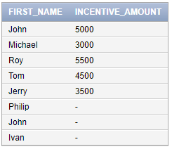
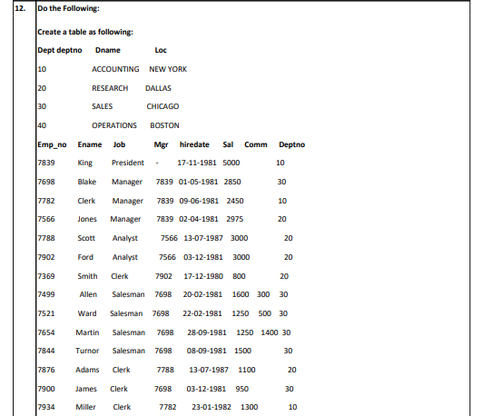
->Create table Department( Deptno number(3) primary key,Dname varchar2(15),Loc varchar2(15));
->describe Department;
->Insert records:
-> insert into Department(Deptno,Dname,Loc) values (10,'ACCOUNTING','NEW YORK');
-> insert into Department(Deptno,Dname,Loc) values (20,' RESEARCH ',' DALLAS');
-> insert into Department(Deptno,Dname,Loc) values (30,' SALES ',' CHICAGO');
-> insert into Department(Deptno,Dname,Loc) values (40,' OPERATIONS ',' BOSTON ');
->select * from Department;
->Create table Employee1( Emp_no number(5) primary key, Ename varchar2(10), Job varchar2(10), Mgr number(5), hiredate date, Sal number(5), Comm number(4), Deptno number(3) references Department);
-> describe Employee1;
1-> insert into Employee1(Emp_no, Ename, Job, Mgr, hiredate, Sal, Comm, Deptno) values (7839,'King','President','',TO_DATE('17-11-1981','DD/MM/YYYY'),5000,'',10);
->select * from Employee1;
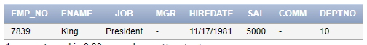
2-> insert into Employee1(Emp_no, Ename, Job, Mgr, hiredate, Sal, Comm, Deptno) values (7698,'Blake','Manager', 7839,TO_DATE('01-05-1981','DD/MM/YYYY'),2850,'',30);
3->
insert into Employee1(Emp_no, Ename, Job, Mgr, hiredate, Sal, Comm, Deptno) values (7782,'Clerk','Manager', 7839,TO_DATE('09-06-1981','DD/MM/YYYY'),2450,'',10);
4-> insert into Employee1(Emp_no, Ename, Job, Mgr, hiredate, Sal, Comm, Deptno) values (7566,'Jones','Manager', 7839,TO_DATE('02-04-1981','DD/MM/YYYY'),2975,'',20);
5-> insert into Employee1(Emp_no, Ename, Job, Mgr, hiredate, Sal, Comm, Deptno) values (7788,'Scott','Analyst', 7566,TO_DATE('13-07-1987','DD/MM/YYYY'),3000,'',20);
6-> insert into Employee1(Emp_no, Ename, Job, Mgr, hiredate, Sal, Comm, Deptno) values (7902,'Ford','Analyst', 7566,TO_DATE('03-12-1981','DD/MM/YYYY'),3000,'',20);
7-> insert into Employee1(Emp_no, Ename, Job, Mgr, hiredate, Sal, Comm, Deptno) values (7369,'Smith','Clerk',7902,TO_DATE('17-12-1980','DD/MM/YYYY'),800,'',20);
8->
insert into Employee1(Emp_no, Ename, Job, Mgr, hiredate, Sal, Comm, Deptno) values (7499,'Allen','Salesman',7698,TO_DATE('20-02-1981','DD/MM/YYYY'),1600,300,30);
9-> insert into Employee1(Emp_no, Ename, Job, Mgr, hiredate, Sal, Comm, Deptno) values (7521,'Ward','Salesman',7698,TO_DATE('22-02-1981','DD/MM/YYYY'), 1250,500,30);
10-> insert into Employee1(Emp_no, Ename, Job, Mgr, hiredate, Sal, Comm, Deptno) values (7654,'Martin','Salesman',7698,TO_DATE('28-09-1981','DD/MM/YYYY'), 1250,1400,30);
11-> insert into Employee1(Emp_no, Ename, Job, Mgr, hiredate, Sal, Comm, Deptno) values (7844,'Turnor','Salesman',7698,TO_DATE('08-09-1981','DD/MM/YYYY'),1500,'',30);
12->
insert into Employee1(Emp_no, Ename, Job, Mgr, hiredate, Sal, Comm, Deptno) values (7876,'Adams','Clerk',7788,TO_DATE('13-07-1987','DD/MM/YYYY'),1100,'',20);
13-> insert into Employee1(Emp_no, Ename, Job, Mgr, hiredate, Sal, Comm, Deptno) values (7900,'James','Clerk',7698,TO_DATE('03-12-1981','DD/MM/YYYY'), 950,'',30);

14-> insert into Employee1(Emp_no, Ename, Job, Mgr, hiredate, Sal, Comm, Deptno) values (7934,'Miller','Clerk',7782,TO_DATE('23-01-1982','DD/MM/YYYY'), 1300,'',10);
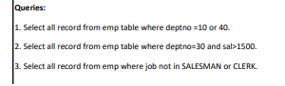
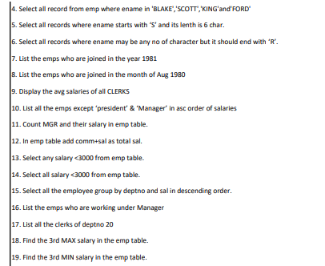
1->[ Select all record from emp table where deptno =10 or 40.]
->select * from employee1 where deptno=10 or deptno=40;
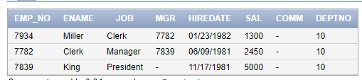
2->[ Select all record from emp table where deptno=30 and sal>1500.]
->select * from employee1 where deptno=30 and sal>1500;
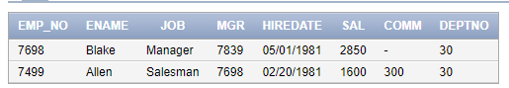
3->[ Select all record from emp where job not in SALESMAN or CLERK.]
->select * from employee1 where job not in ('Salesman','Clerk');
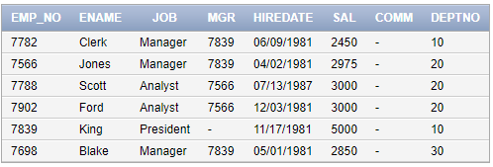
4->[ Select all record from emp where ename in 'BLAKE','SCOTT','KING'and'FORD']
->select * from employee1 where ename in ('Blake','Scott','King','Ford');
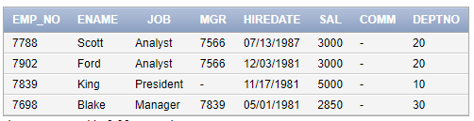
5->[ Select all records where ename starts with ‘S’ and its lenth is 5 char.]
->select * from employee1 where ename like 'S%' and length (ename) =5;
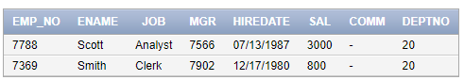
6->[ Select all records where ename may be any no of character but it should end with ‘R’.]
->select * from employee1 where ename like '%r';
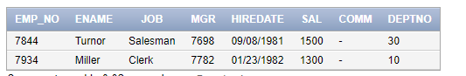
7->[ List the emps who are joined in the year 1981]
-> select * from employee1 where to_char(hiredate,'yyyy')='1981';
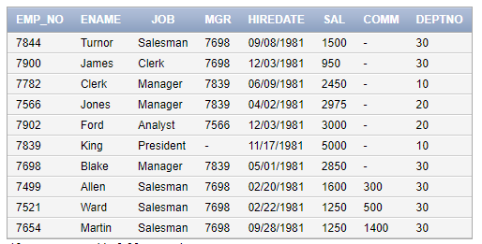
8->[ List the emps who are joined in the month of Dec 1981]
-> select * from employee1 where to_char(hiredate,'yyyy')='1981' and to_char(hiredate,'Mon')='Dec';
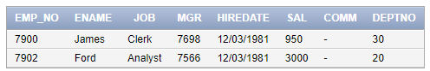
9->[ Display the avg salaries of all CLERKS]
-> select avg(sal) from employee1 group by job having job='Clerk';
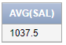
10->[ List all the emps except ‘president’ & ‘Manager’ in asc order of salaries]
-> select * from employee1 where job not in ('President','Manager') order by sal asc;
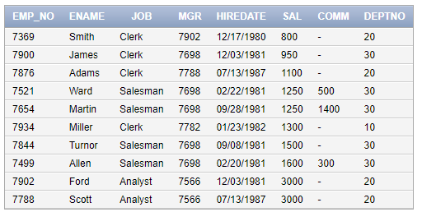
11->[ Count MGR and their total salary in emp table.]
-> select count(sal),sum(sal) from employee1 where job='Manager';
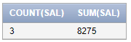
12->[ In emp table add comm+sal as total sal.]
->select emp_no,ename,job,comm+sal "Total Sal" from employee1;
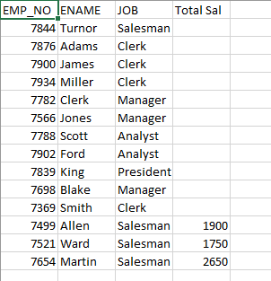
13-> [Select any salary <3000 from emp table.]
-> select * from employee1 where sal<3000;
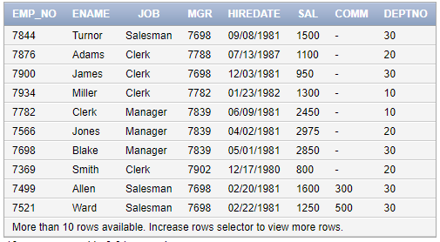
14->[ Select all salary <3000 from emp table.]
->select * from employee1 where sal<3000;
15->[ Select all the employee group by deptno and sal in descending order.]
->select deptno,round(avg(sal),1) from employee1 group by deptno order by avg(sal) desc;
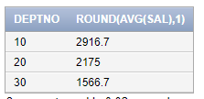
16->[ List the emps who are working under Manager]
->select * from employee1 where mgr in (7566,7698,7782);
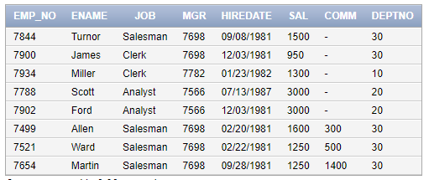
17->[ List all the clerks of deptno 20]
->select * from employee1 where job='Clerk' and deptno=20;
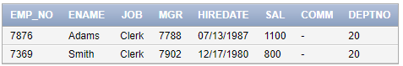
18->[ Find the 3rd MAX salary in the emp table.]
->SELECT * FROM (SELECT * FROM EMPLOYEE1 ORDER BY SAL DESC) WHERE ROWNUM <=3;
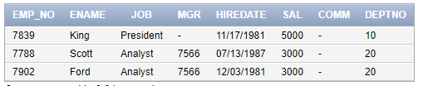
19->[ Find the 3rd MIN salary in the emp table.]
->SELECT * FROM (SELECT * FROM EMPLOYEE1 ORDER BY SAL ASC) WHERE ROWNUM <=3;
